# Q2. Image smoothing using mean_shift

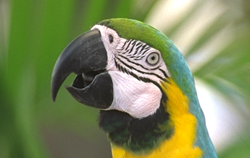

Before smoothing

After smoothing with alpha = 10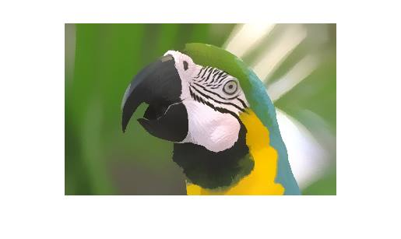

Segmented Parrot:

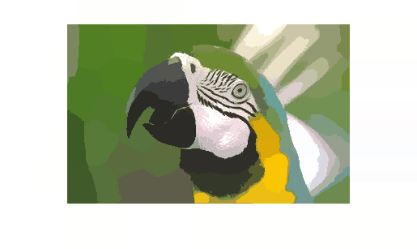

Flower

**Original image**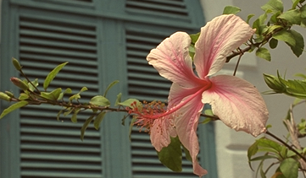

**Smooth image : with alpha = 0.1**

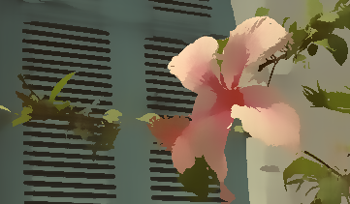

**Segmented Flower**

